Hcronin login setting

Romie: For each of these ‘extra values’, you enter the name and value, and in the # column enter ‘1’. In rare cases we could have multiples, that’s why I put in a # column.

Your entry was:

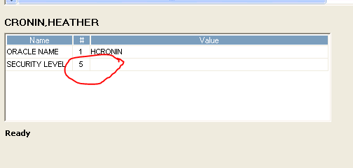

Should be:

